KoWhat is var,const and let?

const` is a signal that the identifier won't be reassigned. `let`, is a signal that the variable may be reassigned, such as a counter in a loop, or a value swap in an algorithm. It also signals that the variable will beused only in the block it's defined in, which is not always the entire containing function.

var declarations are globally scoped or function scoped while let and constare block scoped. ... They are all

hoisted to the top of their scope but while var variables are initialized with undefined , let const veriety are not initialized

What is different between var,const and let?

var and let are both used for function declaration in javascript but the difference between them is

that var is function scoped and let is block scoped. It can be said that avariable declared with var is defined throughout the program as compared to let.

Example of var

nsider some examples of risk measures. These will introduce basic concepts and standard notation. They will also illustrate a framework for thinking about value-at-risk measures (and, more generally, measures of PMMRs), which we shall formalize .

he *Leavens PMMR*

Value-at-risk metrics first emerged in finance during the 1980s, but they were preceded by various other PMMRs, including Markowitz’s ([1952](https://www.value-at-risk.net/references/#Markowitz_1952)) variance of simple return. Even earlier, Leavens ([1945](https://www.value-at-risk.net/references/#Leavens_1945)) published a paper describing the benefits of diversification. He accompanied his explanations with a simple numerical example:

Measure time *t* in appropriate units. Let time *t* = 0 be the current time. Leavens considers a portfolio of 10 bonds over some horizon [0, 1]. Each bond will either mature at time 1 for USD 1000 or default and be worthless.

Events of default are assumed independent. The portfolio’s market

value at time 1 is given by the sum of the individual bonds’ accumulated

values  at time 1:

[1.6]

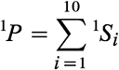

Let’s express this relationship in matrix notation. Let be a random vector with components . Let **ω** be a row vector whose components are the

portfolio’s holdings in each bond. Since the portfolio holds one of

each, **ω** has a particularly simple form:

[1.7]



With this matrix notation, [1.6] becomes the product:

[1.8]



Let 1|0ϕ*i* denote the probability function, conditional on information available at time 0, of the *ith* bond’s value at time 1:

[1.9]

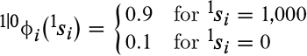

Measured in USD 1000s; the portfolio’s value has a binomial distribution with parameters *n* = 10 and *p* = 0.9. The probability function is graphed .

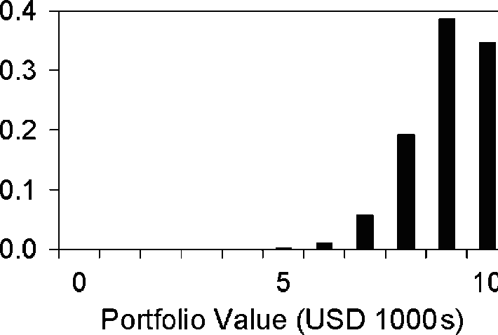xhibit 1.3: The market value (measured in USD 1000s) of Leavens’ bond

portfolio has a binomial distribution with parameters 10 and 0.9.

Writing for a non-technical audience, Leavens does not explicitly identify a

risk metric, but he speaks repeatedly of the “spread between probable losses and gains.” He seems to have the standard deviation of portfolio

market value in mind. For the portfolio in his example, that PMMR has the value USD 948.69.

Our next two examples are more technical. Many readers will find them simple. Other readers—those whose mathematical background is not as strong—may find them more challenging. A note for each group:

For the first group, the examples may tell you things you already know, but in a new way. They introduce notation and a framework for thinking about value-at-risk that will be employed throughout the text. At points,

explanations may appear more involved than the immediate problem requires. Embrace this complexity. The framework we start to develop in the examples will be invaluable in later chapters when we consider more complicated value-at-risk measures.

For the second group, you do not need to master the examples on a first reading. Don’t think of them as a main course. They are not even an appetizer. We are taking you back into the kitchen to sample a recipe or

two. Don’t linger. Taste and move on. In Chapters 2 through 5, we will step back and explain the mathematics used in the examples—and used in value-at-risk measures generally. A purpose of the examples is to provide practical motivation for those upcoming discussions.

There is a useful formula that we will use in the next two examples. We introduce it here for use in those examples but will cover it again in more detail in [Section 3.5](https://www.value-at-risk.net/linear-polynomials-of-random-vectors/).

Let ***X*** be a random vector with covariance matrix **Σ**. Define random variable *Y* as a linear polynomial

[1.10]



of ***X***, where ***b*** is an *n*-dimensional row vector and *a* is a scalar. The variance of *Y* is given by

[1.11]



where a prime ′ indicates transposition. Formula [1.11] is a quintessential formula for describing how correlated risks combine, but there is a caveat. It only applies if *Y* is a linear polynomial of ***X***.

*Exercises*

1.10

Using a spreadsheet, extend Leavens’ analysis to a bond portfolio that holds

20 bonds.

Graph the resulting probability function for .

Value Leavens’ “spread between probable losses and gains” PMMR for the

portfolio?

**Example of const..**

The example demonstrates how constants behave. Try this in your browser console.

*// NOTE: Constants can be declared with uppercase or lowercase, but a common*

*// convention is to use all-uppercase letters.*

*// define MY_FAV as a constant and give it the value 7 const MY_FAV = 7;*

*// this will throw an error - Uncaught TypeError: Assignment to constant variable.*

*MY_FAV = 20;*

*// MY_FAV is*

Example of let

var carName = "Volvo";

// code here can use carName

function myFunction() {

// code here can also use carName

}